----------------------------------------------------------------------------------------------------------------
NAME: VISHAL.V
REG.NO: 192419033
COURSE CODE: ECA0404
COURSE NAME: ANALOG CIRCUITS
PRACTICAL LAB RESULTS
----------------------------------------------------------------------------------------------------------------
EXP-9 (LT spice experiment)
CIRCIUT DIAGRAM:
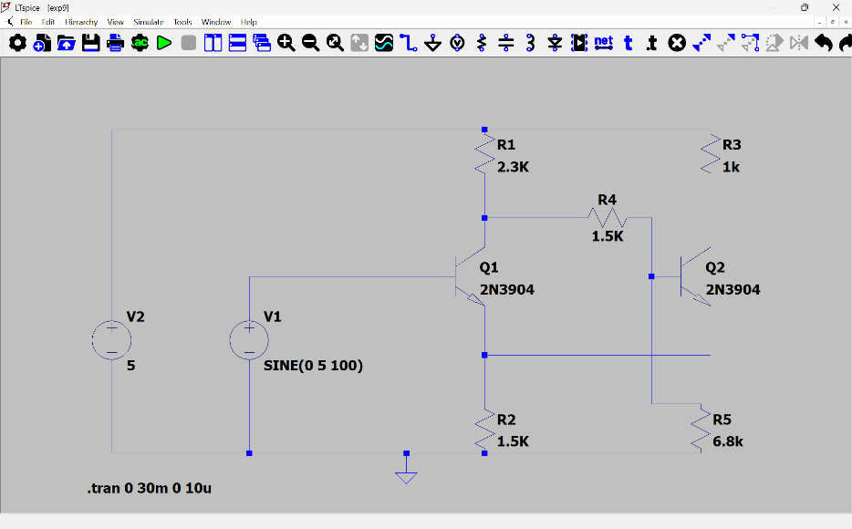

Procedure:
1.Connections are made as shown in the circuit diagram.
2. The DC power supply is switched ON.
3. The output waveform is displayed on the CRO.
4. The peak-to-peak Amplitude and time period of the sine wave is noted.
5. The graph of output waveform is drawn.

OUTPUT(GRAPH): -
